SCHEDULE 1. CONDITIONS OF CONSENT
Parameters of consent
Approved plans and supporting documentation
Development must be carried out in accordance with the following approved plans and supporting documentation (stamped by Council), except where the conditions of this consent expressly require otherwise.

Plan No. | Plan Title | Drawn by | Dated
DA 005 Rev. 03 | Drawing Register | Mana | 17-04-2025
DA 010 Rev. 04 | Master Plan | Mana | 01-05-2025
DA 015 Rev. 03 | Car Parking Position | Mana | 17-04-2025
DA 100 Rev. 03 | Existing Site Plan | Mana | 17-04-2025
DA 101 Rev. 04 | Demolition Site Plan | Mana | 17-04-2025
DA 102 Rev. 05 | Proposed Site Plan | Mana | 17-04-2025
DA 150 Rev. 03 | External Works – Ground Floor | Mana | 17-04-2025
DA 151 Rev. 01 | External Works – Level 1 | Mana | 17-04-2025
DA 200 Rev. 05 | Servies Floor Plan | Mana | 17-04-2025
DA201 Rev. 06 | Ground Floor Plan | Mana | 17-04-2025
DA 202 Rev. 06 | Level 01 Floor Plan | Mana | 01-05-2025
DA 203 | Level 02 Floor Plan | Mana | 01-05-2025
DA 204 Rev. 05 | Roof Plan | Mana | 17-04-2025
DA 300 Rev. 05 | Elevations – Easy Street | Mana | 17-04-2025
DA 301 Rev. 05 | Elevations – Wallum Place | Mana | 17-04-2025
DA 302 Rev. 05 | Elevations – Gallagher St. & Terraces | Mana | 17-04-2025
DA 303 | Elevations – Podium North East | Mana | 17-04-2025
DA 304 Rev. 04 | Elevations – Podium South West | Mana | 17-04-2025
DA 305 Rev. 04 | Elevations – Wallum Pl Internal SW | Mana | 17-04-2025
DA 306 Rev. 04 | Elevations – Wallum Pl Internal NE | Mana | 17-04-2025
DA 307 Rev. 04 | Elevations – East St Internal SW | Mana | 17-04-2025
DA 308 Rev. 04 | Elevations – East St Internal NE | Mana | 17-04-2025
DA 400 Rev. 04 | Sections A-A, B-B, C-C | Mana | 17-04-2025
DA 401 Rev. 03 | Sections D-D | Mana | 17-04-2025
DA 402 Rev. 01 | Sections E-E | Mana | 17-04-2025
DA 500 Rev. 04 | Building RL to Existing NGL | Mana | 17-04-2025
DA 501 Rev. 02 | Building Height to Adjacent Lots | Mana | 17-04-2025
DA 600 Rev. 02 | Terraces Sheds Ground Floor Plan | Mana | 17-04-2025
DA 601 Rev. 02 | Terraces Sheds Roof Plan | Mana | 17-04-2025
DA 602 Rev. 02 | Terrace Sheds GF Plan Detail | Mana | 17-04-2025
DA 603 Rev. 02 | Terraces Sheds Elevation A01 & A-02 | Mana | 17-04-2025
DA 604 Rev. 02 | Terraces Sheds Elevation A03 & A-04 | Mana | 17-04-2025
DA 605 Rev. 02 | Terraces Sheds Elevation A05 & A-06 | Mana | 17-04-2025
DA 606 Rev. 02 | Terraces Sheds Elevation B01 & B-02 | Mana | 17-04-2025
DA 607 Rev. 02 | Terraces Sheds Elevation B03 & B-04 | Mana | 17-04-2025
DA 608 Rev. 02 | Terraces Sheds Elevations | Mana | 17-04-2025
DA 700 Rev. 02 | External Finishes and Assemblies | Mana | 17-04-2025
DA 950 Rev. 02 | Typical Apartment Fit Out Plans 01 | Mana | 29-04-2025
DA 951 Rev. 02 | Typical Apartment Fit Out Plans 02 | Mana | 29-04-2025
DA 952 Rev. 02 | Adaptable & Accessible Apartments | Mana | 29-04-2025
DA 960 Rev. 03 | Wellness Space & Business Hub | Mana | 17-04-2025
DA 985 Rev. 04 | Services Floor Compliance | CPTED | Mana | 17-04-2025
DA986 Rev. 05 | Ground Floor Compliance | CPTED | Mana | 17-04-2025
DA 987 Rev. 05 | Level 1 Compliance | CPTED | Mana | 17-04-2025
DA 988 Rev. 05 | Level 2 Compliance | CPTED | Mana | 17-04-2025
7213-05 SK07 Issue F | Stage 5 Stormwater & Finish Ground Floor Level Plans (Annotated by Council) | Ardill Payne & Partners | 14/05/2026
7213-05 SK10 Issue B | Stage 5 Stormwater & Finish Ground Floor Level Plans (Annotated by Council) | Ardill Payne & Partners | 14/05/2026
Habitat Stage 5 Public Art, Pages 1-16. | Public Art Plan | Plummer and Smith | 01-04-2022

Supplementary Plans

26889 Rev. C  Pages 1-17 | Landscaping Plan | LARC | 14-06-2026
2001 Rev. B | CPTED – SE Walkway | Creative Capital | Undated
DA 986 Rev. 05 | CPTED – Ground Floor Compliance | Creative Capital | 11/04/2025
025 Rev. B | Stage 05 Car Parking Position | Creative Capital | Undated
026 Rev. B | Site Wide Car Parking Position | Creative Capital | Undated
5_1017.5187 | Bulk Bin Storage Room | Planners North | Undated

In the event of any inconsistency between the approved plans and the supporting documentation, the approved plans prevail. In the event of any inconsistency between the approved plans and a condition of this consent, the condition prevails.

Note: an inconsistency occurs between an approved plan and supporting documentation or between an approved plan and a condition when it is not possible to comply with both at the relevant time.

Payment of security deposits (if applicable)
Before the commencement of any works on the site or the issue of a construction certificate, the applicant must make all of the following payments to Council and provide written evidence of these payments to the certifier:
Security deposit | $ 10,000
Inspection fee | $180

The Payments will be used for the cost of:

- making good any damage caused to any council property (including street trees) as a consequence of carrying out the works to which the consent relates,
- completing any public work such as roadwork, kerbing and guttering, footway construction, stormwater drainage and environmental controls, required in connection with this consent, and
- any inspection carried out by Council in connection with the completion of public work or the making good any damage to council property.

Note: The inspection fee includes Council’s fees and charges and includes the Public Road and Footpath Infrastructure Inspection Fee (under the Roads Act 1993). The amount payable must be in accordance with council’s fees and charges at the payment date.

Support for neighbouring buildings
If an excavation extends below the level of the base of the footings of a building on an adjoining allotment of land, the person causing the excavation to be made or builder must:

a. Inform the neighbouring property owner immediately.
b. Engage a structural engineer to determine any remedial works that may need to be undertaken.
c. Preserve and protect the adjoining building from damage.
d. If necessary, underpin and support the building in an approved manner.

Conditions prescribed by the Regulation
This development consent is subject to the conditions prescribed by the regulations in accordance with subsection 4.17(11) of the Environmental Planning and Assessment Act 1979. Conditions are provided in Schedule 2 of this consent.

Integrated Approvals from other State Government Approval Bodies
This development consent includes an Integrated development approval under Sections 4.46 and 4.47 of the Environmental Planning and Assessment Act 1979, being a Bush Fire Safety Authority under s100B of the Rural Fires Act 1997 and is subject to the General Terms of Approval from the NSW Rural Fire Service, dated 13 February 2026, contained in Schedule 3 of this Notice of Determination.

Modification of Development Consent No. 10.2017.628.4 (Habitat Stage 3)
Pursuant to Section 4.17(1)(b) of the Environmental Planning and Assessment Act 1979, this development consent modifies Development Consent No. 10.2017.628.4 (as modified) for 60 Pocket Living Apartments and Subdivision to Create One Additional Community Title Lot, issued 24 July 2018.
The purpose of the modification is to consolidate public art requirements for Habitat Stage 3 into Habitat Stage 5.
Development Consent 10.2017.628.4 is hereby modified as follows:
- Delete Condition 32A.

Modification of Development Consent No. 10.2019.517.2 (Habitat Stage 4)
Pursuant to Section 4.17(1)(b) of the Environmental Planning and Assessment Act 1979, this development consent modifies Development Consent No. 10.2019.517.2 (as modified) for Mixed Use Development (Habitat Stage 4), issued 21 May 2020.
The purpose of the modification is to consolidate public art requirements for Habitat Stage 4 into Habitat Stage 5.
Development Consent 10.2019.517.2 is hereby modified as follows:
- Delete Condition 14.

The following conditions are to be complied with prior to issue of a Construction Certificate for building works
Notice of Modification of Development Consent to be submitted to Council
A Notice of Modification of Development Consent, prepared in accordance with Clause 67 of the Environmental Planning and Assessment Regulation 2021, must be submitted to Council with respect to Development Consent No. 10.2017.628.4.

The Notice of Modification is to include the following:

  - The name and address of the person by whom the notice is given.
  - The address, and formal particulars of title, of the land to which the consent relates.
  - A description of the development consent to be modified consistent with Condition 6 of this Development Consent.
  - A written statement agreeing that the consent is to be modified in accordance with Condition 6 of this consent.
  - If the Applicant is not the owner of the land, a statement by the owner of the land to the effect that the owner consents to the modification of the consent.

Note. The Notice of Modification takes effect when it is received by Council. The Notice of Modification will operate, according to its terms, to modify the development consent to which it relates.

Notice of Modification of Development Consent to be submitted to Council
A Notice of Modification of Development Consent, prepared in accordance with Clause 67 of the Environmental Planning and Assessment Regulation 2021, must be submitted to Council with respect to Development Consent No. 10.2019.517.2.

The Notice of Modification is to include the following:

  - The name and address of the person by whom the notice is given.
  - The address, and formal particulars of title, of the land to which the consent relates.
  - A description of the development consent to be modified consistent with Condition 7 of this Development Consent.
  - A written statement agreeing that the consent is to be modified in accordance with Condition 7 of this consent.
  - If the Applicant is not the owner of the land, a statement by the owner of the land to the effect that the owner consents to the modification of the consent.

Note. The Notice of Modification takes effect when it is received by Council. The Notice of Modification will operate, according to its terms, to modify the development consent to which it relates.

Long Service Levy to be paid
In accordance with section 6.8 of the Environmental Planning and Assessment Act 1979 (as amended), a construction certificate for subdivision works or building works shall not be issued until any Long Service Levy payable under section 34 of the Building and Construction Industry Long Service Payments Act 1986 (or where such levy is payable by instalments, the first instalment of the levy) has been paid (as applicable).

These payments can be made online at www.longservice.nsw.gov.au. Proof of payment is required to be submitted with the construction certificate application. For further information regarding the long service payment please refer to the website above.

Certificate of Compliance – s307 Water Management Act 2000
Prior to issue of any Construction Certificate, a Certificate of Compliance under Section 307 of the Water Management Act 2000 must be obtained upon payment of developer charges for water and sewer as calculated in accordance with Byron Shire Council and Rous County Council Development Servicing Plans. Where staging of the Construction Certificate occurs, a separate s307 Compliance Certificate must be obtained for each stage.

Byron Shire Council acts as Rous County Council’s agent in this matter and will issue a Certificate of Compliance on behalf of Rous County Council upon payment of the Rous County Council Development Servicing Charge to this Council.
Note: For issue of the Certificate of Compliance, an application form and associated fee must be lodged via Council’s website. Copies of Byron Shire Council’s Development Servicing Plans are available via Council’s website.
Developer charges will be calculated in accordance with the Development Servicing Plan applicable at the date of payment. A check must be made with Council to ascertain the current rates by contacting Council’s Principal Engineer Systems Planning, Utilities on 02 6626 7000. Applicable charges can also be found on Council’s website: https://www.byron.nsw.gov.au/Services/Water-sewer/Plumbers-and-developers/Calculate-the-cost-of-an-Equivalent-Tenement#section-3

The contributions payable will be adjusted in accordance with relevant plan and the amount payable will be calculated on the basis of the contribution rates that are applicable at the time of payment.

Payment by Personal or Company Cheque will not be Accepted

Developer Contributions to be paid
Contributions set out in the schedule / notes at the end of this consent are to be paid to Council prior to the release of any construction certificate. Contributions are levied in accordance with the Byron Shire Developer Contributions Plan 2012 (as amended).

The Developer Contribution Plan can be viewed online or using the Customer Kiosk during office hours at the Council Offices located at Station Street, Mullumbimby. These contributions are to fund public amenities and services as listed in the schedule. Additional details on the specific amenities are to be found in the Byron Shire Developer Contributions Plan 2012 (as amended).

The contributions in the schedule are current at the date of this consent. The contributions payable will be adjusted in accordance with the relevant plan and the amount payable will be calculated on the basis of the contribution rates that are applicable at the time of payment. The schedule contains a date for which the schedule remains valid, after this date you will have to contact Council for an updated schedule.

Contact Council for payment options.

Water and Sewerage - Section 68 approval required
If required, an approval under Section 68 of the Local Government Act 1993 to carry out water supply work and sewerage work must be obtained.

Consent required for works within the road reserve
Consent from Council must be obtained for works within the road reserve pursuant to Section 138 of the Roads Act 1993. Three (3) copies of engineering construction plans must accompany the application for consent for works within the road reserve.

Such plans are to be in accordance with Council’s current Design & Construction Manuals and are to provide for the following works:

Driveway (Wallum Pl) | A driveway in accordance with Council’s standard “Northern Rivers Local Government Development Design & Construction Manuals and Standard Drawings”. The footpath crossing must be designed to provide a cross fall of 1 % or 1:100 (maximum 2.5% or 1 in 40) for a width of at least 2.4 metres to provide for pedestrians with access disabilities.  The following must be considered:  - Access Width  The access driveway width must Be designed in accordance with AS2890.2.  - On-Site Manoeuvring Area  The manoeuvring area shall be designed in accordance with AS2890.2  - Vehicle Manoeuvring  Swept path analysis must be submitted, prepared by a suitably qualified professional, demonstrating that the nominated/maximum design vehicle has been designed to manoeuvre in accordance with AS2890.2.
Footpath | A concrete footpath (minimum) 2.1 metres wide must be provided to the entire frontage at Wallum Place from the corner of Porter Street to the corner of Gallagher Street. Existing stormwater infrastructure is to be adjusted as required.
Dilapidation Reports required | - Prior to the commencement of any excavation works requiring rock drilling, blasting or breaking, a pre-construction Dilapidation Report is to be submitted to Council detailing the current condition of all adjoining buildings, infrastructure and roads.

Traffic Management Plan
Consent from Council must be obtained for a Traffic Management Plan pursuant to Section 138 of the Roads Act 1993. The plans and specifications are to include the measures to be employed to control traffic (inclusive of construction vehicles) during construction of the development. The traffic management plan is to be designed in accordance with the requirements of the Roads and Traffic Authority’s Manual, Traffic Control at Work Sites Version 2, and the current Australian Standards, Manual of Uniform Traffic Control Devices Part 3, ‘Traffic Control Devices for Works on Roads’.

The report must incorporate measures to ensure that motorists using road adjacent to the development, residents and pedestrians in the vicinity of the development are subjected to minimal time delays due to construction on the site or adjacent to the site.

The traffic management plan must be prepared by a suitably qualified and RTA accredited Work Site Traffic Controller.

Easement required over pipelines
In all new subdivisions and/or developments, an easement in gross benefitting Byron Shire Council shall be provided for all pipelines in accordance with the Council Policy: Building in the Vicinity of Underground Infrastructure 2020.

Easement documentation shall be prepared in accordance with NSW Land Registry Services requirements over the pipeline/s within the allotment/s. Easement documentation must be submitted to Council for execution, together with a survey showing location, size and depth of the pipeline/s and payment of fees in accordance with Council’s adopted fees and charges.

Prior to issue of the construction certificate, proof of lodgement to NSW Land Registry Services must be provided to the Principal Certifying Authority.

The minimum width of the required easement shall be 2 metres along the northeastern boundary.

Car parking layout, vehicle circulation and access plans required
The application for a Construction Certificate is to include plans and specification that indicate access, parking and manoeuvring details, in accordance with the plans approved by this consent.

The access, parking and manoeuvring for the site is to comply with the requirements of AS 2890.1-2004: Parking facilities, Part 1: Off-street car parking and AS 2890.2 – 2010 - Parking facilities, Part 2: Off-street commercial vehicle facilities.

Plans are to include, but not be limited to, the following items.

- The development must provide the 8 residential and 1 commercial accessible parking spaces in accordance with AS/NZS 2890.6.
- The applicant must submit detailed plans and supporting documentation demonstrating:
- Compliance with relevant Australian Standards, including AS 2890 series
- Compliance with accessible parking design requirements, including gradients, access routes, and circulation
- Applicable user class for residential, commercial and accessible parking to be User class 1 in accordance with AS2890.1 and user class 4 in accordance with AS2890.6
- Provide adequate vertical clearance within the loading bay area (ducting, pipes under the ceiling must be considered);
- Maintain grades consistent with safe waste vehicle operation.

- Service bay designed to accommodate
- MRV Vehicle according to Table 2.1 of AS2890.2; and
- SRV Vehicle according to Table 2.1 of AS2890.2.

- EV ready parking spaces
- Commercial
- A minimum of 10% of the total number of commercial parking spaces must be provided as EV-ready spaces;
- EV-ready spaces must include installation of appropriate conduit and electrical capacity to enable the future installation of Level 2 (public) or higher EV charging stations; and
- Distribution boards and electrical infrastructure are to be sized to Residential Flat Buildings.
- Residential
- Each dwelling must be provided with at least one car parking space capable of supporting EV charging;
- This is to include installation of conduit and sufficient electrical capacity to enable future installation of a Level 1 (minimum 16A single-phase) EV charging point for that space.
- All EV-ready infrastructure to be designed and installed in accordance with relevant Australian Standards and electrical regulations.

- pavement design, comprising an all-weather surface, such as asphalt, bitumen seal, concrete;
- site conditions affecting the access;
- existing and design levels;
- longitudinal section from the road centreline to the car space(s);
- cross sections every 15 metres;
- drainage details;
- turning paths; and
- line marking and signage.

The engineering plans and specifications are to be designed by a qualified practising Civil Engineer. The Civil Engineer is to be a corporate member of the Institution of Engineers Australia or is to be eligible to become a corporate member and have appropriate experience and competence in the related field.

Such plans and specifications must be approved as part of the Construction Certificate.

NOTE: The plans must be in compliance with Council's current “Northern Rivers Local Government Development Design & Construction Manuals and Standard Drawings”.

Amended Operational Waste Management Plan
Prior to the issue of a construction certificate, an amended operational waste management plan (OWMP) must be submitted to Council for endorsement.

The OWMP must include, but not be limited to, the following information:

    - Details relating to the types of waste streams likely to be generated and estimate of volumes of waste material generated and managed.
    - Detailed information on waste and recycling storage.
    - Detailed information on waste and recycling collection / servicing arrangements.
    - Adequate plans to demonstrate the location of skip bins and servicing from waste collection vehicles.
    - Details of relevant signage.

- The bulk bin servicing point shall be designed in accordance with the following requirements:

- Sufficient access and clearance for the waste collection vehicle to service bins, taking into consideration the waste collection vehicle operating dimensions.
- The bulk bin servicing point must be separation for any car parking bays, loading bays, footpaths and pedestrian pathways or areas.
- The bulk bin servicing point must be clear of speed control devices or similar which inhibit direct access to the bins for servicing.
- Must be constructed using hardstand with sold concrete base or acceptable equivalent.

- The bulk bin storage area must be located and constructed within a purpose-built storage room, in accordance with Waste Store Detailed Plans prepared by Planners North dated 16 February 2026 (Ref. S_1017.5187).

The design and construction of the storage room must comply with the following requirements:

- Air-locked.
- Fly and vermin proofed.
- Used solely for the storage of waste.
- Provided with mechanical ventilation.
- Constructed hardstand area with a solid concrete base or acceptable equivalent.
- Graded to fall to a drainage point.
- Drainage points to be connected to sewer in accordance with liquid trade waste requirements.
- Provided with a hose cock for cleaning the bins.
- Allows for the provisions of 9 x 240L FOGO bins for the residential component of the building.

The Council endorsed OWMP and any amended plans necessary to comply with the above requirements must be submitted for approved with the construction certificate application.

Amended Stormwater Drainage Plan
The application for a Construction Certificate is to include plans and specifications for stormwater drainage in accordance with AS/NZS 3500.3:2003, Plumbing and drainage, Part 3: Stormwater drainage. All stormwater drainage for the development must be conveyed by a gravity system to the existing stormwater drainage system within the site in accordance with the approved plans.

Such plans and specifications must be approved as part of the Construction Certificate.

The following requirements must be addressed:

- Amendment to Stormwater Treatment System
The proposed infiltration system is not approved and must be removed. The design is to be amended to incorporate a suitable proprietary stormwater treatment device(s) that is appropriate to the site constraints and capable of achieving Council’s adopted stormwater quality objectives.

- Stormwater Quality Management Report
A Stormwater Quality Management Report is to be prepared by a suitably qualified and experienced person. The report must demonstrate compliance with the water quality objectives specified in Table B3.1 of Chapter B3 of BDCP 2014.

- MUSIC Modelling
MUSIC modelling is to be undertaken to support the proposed stormwater treatment measures. The modelling must demonstrate that the development achieves the required pollutant load reduction targets specified in BDCP 2014.

- Stormwater Management Plan
A fully detailed Stormwater Management Plan is to be submitted, which includes, but is not limited to:
- Detailed design drawings and technical specifications for all stormwater treatment devices
- Hydraulic design and sizing calculations
- Site layout plans showing the location and configuration of the stormwater system

- Operation and Maintenance Plan
A Stormwater Quality Management and Maintenance Plan is to be submitted, detailing:
- Ongoing operation and maintenance requirements for all stormwater treatment measures in accordance with the manufacturer’s specification
- A signed 5-year maintenance contract agreement with the manufacturer specialist technician. The maintenance contract to include a renewal arrangement regime to ensure SQIDs are maintained in accordance with the manufacturer’s specification at all times.

- Lifecycle Assessment
A Lifecycle Assessment for the proposed stormwater treatment system is to be provided, including:
- Expected design life of all treatment devices.
- Replacement and renewal requirements.
- Whole-of-life cost analysis and long-term performance considerations.

- OSD for the site generally in accordance with the approved plans
All stormwater drainage systems within the lot and the connection to a public or an inter-allotment drainage system must:

        - comply with any requirements for the disposal of stormwater drainage contained in Council’s Development Control Plan, Stormwater Guideline and Local Approvals Policy; and
        - unless exempt from obtaining an approval under section 68 of the Local Government Act 1993 by a Local Approvals Policy, an approval must be obtained under that Act prior to issue of a Construction Certificate.

Additional car wash bay
The proposed development incudes 1 car wash bay for 78 apartments which does not satisfy the requirements of Byron Development Control Plan 2014 and is insufficient for the scale of the development.

The plans submitted for approval with the construction certificate application must be amended to include one additional car wash bay (two in total). The additional car wash bay can be located within the ground floor car parking area of the Stage 5 building, or elsewhere in the habitat complex, provided the wash bay is in a safe and convenient location for residents.

The registered certifier shall be satisfied that amended plans in accordance with the above requirement are submitted for approval as part of the construction certificate application.

Noise and Vibration Construction Management Plan required
A Noise and Vibration Construction Management Plan must be submitted to and endorsed by Council prior to the issue of the construction certificate for building works. The Noise and Vibration Construction Plan must be prepared by a duly qualified professional and detail the methods that will be implemented for the whole project to minimise construction noise and vibration.

Information must include:

- Identification of the specific activities likely to generate noise or vibration impacts.
- Identification of nearby residences and other sensitive land uses.
- Identification of all potentially affected sensitive receivers.
- Assessment of expected noise and vibration from the construction activities construction activities that are likely to affect their amenity or cause structural damage through vibration.
- Detailed examination of feasible and reasonable work practices that will be implemented to minimise noise impacts.
- Noise and vibration monitoring, reporting and response procedures.
- Strategies to promptly deal with and address noise complaints.
- Description of specific mitigation treatments, management methods and procedures that will be implemented to control noise and vibration during construction.
- Details of performance evaluating procedures (for example, noise monitoring or checking work practices and equipment).
- Procedures for notifying nearby residents of forthcoming works that are likely to produce noise impacts.
- Reference to relevant consent conditions.
- Name and qualifications of person who prepared the report.
- Nomination of an appropriate responsible person with appropriate qualifications and experience to implement and manage noise and vibration matters arising from the construction phase of the development. The responsible person must be available to receive neighbourhood inquiries and complaints at any time while work is proceeding and must record monitoring levels and response actions when exceedances or complaints occur.
- Contingency plans to be implemented in the event of non-compliance and/or complaints.

Advisory note: Refer to DECC’s ‘Interim Construction Noise Guideline’ (2009) for more information (see Interim Construction Noise Guideline).

The Council endorsed Noise and Vibration Construction Management Plan must be submitted for approval as part of the construction certificate application.

Environmental Management Plan required
An Environmental Management Plan (EMP) must be submitted to Council for endorsement prior to the issue of the construction certificate for building works. The EMP must be prepared by a suitably qualified professional and contain details of measures to be undertaken to ensure that construction works do not result in any off-site impacts that could interfere with neighbourhood amenity. The EMP must also include a Waste Management Strategy that details the management of wastes created as a result of the construction including on-site storage and disposal of building wastes.

The Council endorsed Environmental Management Plan must be submitted for approval as part of the construction certificate application.

Operational Noise Management Plan
An operational noise management plan (NMP) must be prepared and submitted to Council for endorsement prior to the issue of a construction certificate.

The NMP must include, but not be limited to, the following items:

        - identification of nearby residences and other sensitive land uses.
        - an assessment of expected noise impacts.
        - a detailed examination of all feasible and reasonable management
practices that will be implemented to minimise noise impacts.
        - strategies to promptly deal with and address noise complaints.
        - details of performance evaluating procedures.
        - procedures for notifying nearby residents living within 500 metres of the property of forthcoming events, times that they are likely to notice noise emanating from events and the contact details for the onsite manager for complaints and queries to be made and responded to.
        - reference to all relevant consent conditions including hours of operation and number of patrons; and
        - the name and qualifications of person who prepared the report.
        - restricted pool access hours.
        - prohibition of amplified music in pool and common / public areas of the building.

The Council-endorsed NMP must be submitted for approval as part of the construction certificate application.

Geotechnical Report required – Engineering Works
A certificate from a professional Engineer experienced in soil mechanics is to be provided to the Principal Certifying Authority, certifying that:

- the design of the civil engineering works, including retaining walls and/or cut & fill batters, has been assessed as structurally adequate,
- the civil engineering works will not be affected by landslip or subsidence either above or below the works; and
- adequate drainage has been provided

Fibre-ready Facilities and Telecommunications Infrastructure
Unless exempted from Part 20A of the Telecommunications Act 1997, evidence satisfactory to the Certifying Authority must be submitted prior to the issue of the Construction Certificate in connection with a development, that the developer (whether or not a constitutional corporation) has made arrangements for:

- the installation of fibre-ready facilities to all individual lots and/or premises in a real estate development project so as to enable fibre to be readily connected to any premises that is being or may be constructed on those lots. Demonstrate that the carrier has confirmed in writing that they are satisfied that the fibre ready facilities are fit for purpose; and
- the provision of fixed-line telecommunications infrastructure in the fibre-ready facilities to all individual lots and/or premises in a real estate development project demonstrated through an agreement with a carrier.

Notes:
        - Real estate development project has the meanings given in section 372Q of the Telecommunications Act; and
        - Exemptions only apply if published on the Register of developments exempted from Part 20A of the Telecommunications Act 1997 issued by the NSW Government Department of Infrastructure, Transport, Regional Development, Communications and the Arts, or similar.

Compliance with Building in the Vicinity of Underground Infrastructure Policy
All developments must comply with Policy: Building in the Vicinity of Underground Infrastructure 2020. Swimming pools are classed as buildings and are required to comply with this policy.

The use of displacement and screw pile construction methods will require approval by Council. Any retaining wall / brick / masonry fence crossing a pipeline requires Council approval. The fence must be supported such that it does not cause loading on the pipes zone-of-influence.

A minimum horizontal clearance of 1.5m from the centre is required around existing access structures and from the outside of the pipeline as well as minimum vertical clearance of 3m from finished ground level is required.

Compliance with BASIX Certificate requirements
The development is to comply with Basix Certificate No. 1792869M, dated 24 April 2025.

The commitments indicated in the Certificate are to be indicated on the plans submitted for approval of the Construction Certificate.

The plans submitted must clearly indicate all windows numbered or identified in a manner that is consistent with the identification on the Basix Certificate. Minor changes to the measures may be undertaken without the issue of any amendment under Section 4.55 of the Act, provided that the changes do not affect the form, shape or size of the building.

Such plans and specifications must be approved as part of the Construction Certificate.

Details of pool fence required
The application for a Construction Certificate is to include plans and specifications that indicate the details of the fence around the swimming pool in accordance with the Swimming Pools Act 1992 and AS1926.1.

Such plans and specifications must be approved as part of the Construction Certificate.

Swimming Pool controlled discharge rate
The swimming pool discharge pipe (sized – maximum 50mm) shall not discharge at a flow rate greater than one litre per second (< 1.0L/s). The discharge of swimming pool backwash water shall not be carried out during rain periods. Such details shall be provided for approval with the construction certificate.

Sediment and Erosion Control Management Plan required
The application for a Construction Certificate is to include plans and specifications that indicate the measures to be employed to control erosion and loss of sediment from the site. Control over discharge of stormwater and containment of run-off and pollutants leaving the site/premises must be undertaken through the installation of erosion control devices such as catch drains, energy dissipaters, level spreaders and sediment control devices such as filter fences and sedimentation basins.

Such plans and specifications must be approved as part of the Construction Certificate.

NOTE: The plans must be in compliance with Council's current “Northern Rivers Local Government Development Design & Construction Manuals and Standard Drawings”.

The following conditions are to be complied with prior to any demolition, site works or building works commencing
Erosion and Sediment Control Management Plan to be implemented
Erosion and sedimentation controls are to be in place in accordance with the approved Erosion and Sediment Control Plan.

Sediment and erosion control measures in accordance with the approved Erosion and Sedimentation Control plan/s must be maintained at all times until the site has been stabilised by permanent vegetation cover or hard surface.

Any such measures that are deemed to be necessary because of the local conditions must be maintained at all times until the site is made stable (i.e. by permanent vegetation cover or hard surface).

Note: Council may impose on-the-spot fines for non-compliance with this condition.

Public safety requirements
All care is to be taken to ensure the safety of the public in general, road users, pedestrians and adjoining property. The public liability insurance cover, for a minimum of $20 million, is to be maintained for the duration of the construction of the development. Council is to be nominated as an interested party on the policy. Council is not held responsible for any negligence caused by the undertaking of the works.

Toilet facilities
Toilet facilities are to be provided, at or in the vicinity of the work site at the rate of one toilet for every 20 persons or part of 20 persons employed at the site.

The following conditions are to be complied with during any demolition, building or construction works
Sediment and erosion controls to be maintained
Sediment and erosion control measures must be maintained at all times in accordance with the approved Sediment and Erosion Control Management Plan until the site has been stabilised by permanent vegetation cover or hard surface.

Environmental Management Plan to be implemented
The approved Environmental Management Plan must be implemented and adhered to at all times during building or construction works. The applicant is required to ensure that all construction staff have been made aware of their responsibility to abide by the plan. A copy of the plan must be located in a prominent position on site at all times.

Noise and Vibration Construction Management Plan to be implemented
The approved Noise and Vibration Construction Management Plan must be implemented and adhered to at all times.

External Lighting
External Lighting must be designed and implemented to be consistent with the requirements of Australian Standard 4282:2023 Control of the obtrusive effects of outdoor lighting.

Stormwater drainage work
Stormwater drainage for the development must be constructed in accordance with the approved plans and specification by a suitably qualified person.

Hours of work
The principal certifier must ensure that building work, demolition or vegetation removal is only carried out between:

- 7am to 6pm on Monday to Friday.
- 8am to 1pm on Saturday.

The principal certifier must ensure building work, demolition or vegetation removal is not carried out on Sundays and public holidays, except where there is an emergency.

Unless otherwise approved within a construction site management plan, construction vehicles, machinery, goods or materials must not be delivered to the site outside the approved hours of site works.

Note: Any variation to the hours of work requires Council’s approval.

Construction Noise
While building work is being carried out, and where a noise and vibration management plan is approved under this consent, the applicant must ensure that any noise generated from the site is controlled in accordance with the requirements of that plan.

Implementation of BASIX commitments
While building work is being carried out, the applicant must undertake the development strictly in accordance with the commitments listed in the BASIX certificate(s) approved by this consent, for the development to which the consent applies.

Signs to be erected on building and demolition sites
A sign must be erected in a prominent position on the work site:

a. stating that unauthorised entry to the work site is prohibited, and
b. showing the name of the person in charge of the work site and a telephone number at which that person may be contacted outside working hours.

Any such sign is to be removed when the work has been completed.

Builders rubbish to be contained on site
All builder’s rubbish is to be contained on the site in a ‘Builders Skips’ or an enclosure. Footpaths, road reserves and public reserves are to be maintained clear of rubbish, building materials and all other items.

Fill to be retained on the subject land
Fill material must not encroach onto any adjoining land.

Prevention of water pollution
Only clean and unpolluted water is to be discharged to Council’s stormwater drainage system or any watercourse to ensure compliance with the Protection of Environment Operations Act.

Note: Council may impose on-the-spot fines for non-compliance with this condition.

Demolition
Any required demolition works must be undertaken in accordance with the relevant requirements of Australian Standard AS 2601–1991: The Demolition of Structures published by Standards Australia, and the WorkCover Authority of NSW.

All excavated soils to be disposed of off-site
All excavated soils to be disposed of off-site and in accordance with NSW EPA Waste Classification Guidelines (2014) and approved environmental management plans.

Removal of demolition and other wastes
All wastes, including asbestos and lead-contaminated wastes, associated with these works are to be handled and disposed of in accordance with the requirements of the Work Cover Authority. The applicant/owner is to produce documentary evidence that this condition has been met. Wastes must be disposed of at a Licenced Waste Facility. All wastes removed from the site must be managed and disposed of in accordance with the NSW EPA Waste Classification Guidelines (2014)

Excavated natural materials and demolition waste disposal
Any and all excavated natural materials and demolition and builders waste transported from the site must be accompanied (a copy kept with the transporter) by a NSW Protection of The Environment Operations Act s143 Notice.

Aboriginal Relics
While demolition or building work is being carried out, all such works must cease immediately if a relic or Aboriginal object is unexpectedly discovered. The applicant must notify the Heritage Council of NSW in respect of a relic and notify the Secretary of the Department of Planning, Industry and Environment and the Heritage Council of NSW in respect of an Aboriginal object. Building work may recommence at a time confirmed by either the Heritage Council of NSW or the Secretary of the Department of Planning, Industry and Environment.

In this condition:

- “relic” means any deposit, artefact, object or material evidence that:
- relates to the settlement of the area that comprises New South Wales, not being Aboriginal settlement, and
- is of State or local heritage significance; and

- “Aboriginal object” means any deposit, object or material evidence (not being a handicraft made for sale) relating to the Aboriginal habitation of the area that comprises New South Wales, being habitation before or concurrent with (or both) the occupation of that area by persons of non-Aboriginal extraction and includes Aboriginal remains.

Site Location
The location of the building on the site to be established by a suitably qualified Surveyor and must comply with this approval including any required setbacks to boundaries.

The following conditions are to be complied with prior to occupation of the building
Public art installation
Prior to the issue of an occupation certificate, the Registered Certifier shall be satisfied that the public art installation has been established in accordance with the approved Public Art Plan.

The art installation is to comprise four or five individual sculptural pieces as stated in the approved public art plan.

Landscaping to be completed
Prior to the issue of an Occupation Certificate, the Registered Certifier must be provided with a certificate or report prepared by a qualified architect or landscape architect certifying that all landscaping, including the site and podium areas, has been completed in accordance with the approved landscaping plan.

CPTED measures to be installed
The Crime Prevention Through Environmental Design (CPTED) measures detailed on the approved CPTED Plans must be implemented prior to the installation of an occupation certificate.

Such measures include but are not necessarily limited to:

- 1.8m security gates (with swipe card or keyed entry) at the SE Walkway behind the Porter Street terraces.
- Wall mounted lighting along the SE walkway.
- CCTV cameras at security gate threshold.
- Bollard lighting in the Pocket Park and Easy Street.
- Brushed concrete surface treatment for the SE walkway.

Access and parking areas to be completed
The access and parking areas are to be constructed in accordance with the approved plans and Roads Act consent.

On-site Stormwater Detention (OSD) and Stormwater Quality Improvement Devices (SQIDs) – Certification of works
All stormwater drainage works, including OSD and SQIDs works, for the development must be constructed in accordance with the approved plans and specification prior to issue of an occupation certificate. Certificate/s of Compliance for the stormwater works must be submitted to the Principal Certifying Authority prior to the issue of an occupation certificate.

The certificate/s are to be prepared by a suitably qualified engineer and must be in accordance with Council’s Comprehensive Guidelines for Stormwater Management.

Easement required over pipelines
The easement over Council pipelines required by conditions of this consent must be registered on title and a copy of the title search and registered easement documentation, including plan of easement, must be submitted to the Registered Certifier prior to the issue of any Occupation Certificate.

Plumbing Works
All works in relation to any associated Section 68 Water and Sewerage approval must be fully complied with and have a Final Plumbing Certificate issued prior to the issue of an Occupation Certificate.”

Site Location Survey
A final survey of the structures showing setbacks to boundaries to be submitted to the Private Certifier with the Occupation Certificate demonstrating compliance with the approved plans.

Swimming pool fencing
Swimming pool fencing is to comply with the requirements of the Swimming Pools Act 1992 and Regulations.

Swimming pool backwash
Pool backwash to be connected to a sewer overflow relief gully.

Compliance with bushfire conditions
Documentary evidence from a suitably qualified professional is to be submitted demonstrating that the bush fire conditions in Schedule 3 of this Notice of Determination have been complied with.

Works to be completed prior to issue of an Occupation Certificate
All of the works indicated on the plans and approved by this consent, including any other consents that are necessary for the completion of this development including approvals issued under the Local Government Act 1993 and the Roads Act 1993, are to be completed and approved by the relevant consent authority/s prior to the issue of an Occupation Certificate.

Any Security bond paid for this application will be held until Council is satisfied that no further works are to be carried out that may result in damage to Councils road/footpath reserve.

The following conditions are to be complied with prior to the issue of a subdivision certificate
Certificate of Compliance – s307 Water Management Act 2000
Water and sewer services are to be provided to the land in accordance with an approval granted under Section 68 of the Local Government Act 1993.
Payment of developer charges to Byron Shire Council for water supply and sewerage.
A copy of the Certificate of Compliance under Section 307 of the Water Management Act 2000 is to be obtained from Byron Shire Council prior to the issue of a Subdivision Certificate. Where staging of the Subdivision occurs, a separate s307 Compliance Certificate must be obtained for each stage.

Note: For issue of the Certificate of Compliance, an application form and associated fee must be lodged via Council’s website. Copies of Byron Shire Council’s Development Servicing Plans are available via Council’s website.
Developer charges will be calculated in accordance with the Development Servicing Plan applicable at the date of payment. A check must be made with Council to ascertain the current rates by contacting Council’s Principal Engineer Systems Planning, Utilities on 02 6626 7000. Applicable charges can also be found on Council’s website: https://www.byron.nsw.gov.au/Services/Water-sewer/Plumbers-and-developers/Calculate-the-cost-of-an-Equivalent-Tenement#section-3

The contributions payable will be adjusted in accordance with relevant plan and the amount payable will be calculated on the basis of the contribution rates that are applicable at the time of payment.

Payment by Personal or Company Cheque will not be Accepted

The following conditions are to be complied with at all times
Public Art
The sculptural installation detailed in the approved Public Art Plan must be installed and maintained in safe condition at all times.

Landscaping to be maintained
The landscaping of the site, including the podium, eastern elevation, and Wallum Place frontage, is to be maintained at all times in accordance with the approved landscaping plan to ensure the establishment and successful growth of plants. This includes but is not limited to watering, weeding, and the replacement of failed plant material.

Operational Noise Management
The approved Operational Noise Management Plan must be implemented and adhered to at all times.

Amplified Music
Amplified music is not permitted in the pool or common areas of this stage (stage 5) of the Habitat development unless authorised by a Stage-specific Noise Management Plan approved by the Council.

Waste Management Plan
The approved Operational Waste Management Plan is to be implemented and adhered to at all times.

Maintenance of Stormwater Quality Improvement Devices (SQIDs) and OSD
All SQIDs & OSD must be maintained in accordance with maintenance plan at all times.

CPTED Measures
The CPTED measures identified on the approved CPTED plans must be implemented and maintained at all times.

Use of Ground Floor Commercial Premises
The ground floor premises are approved for use as either “office premises” or “shops”, in accordance with the approved plans and the land use definitions in the Byron Local Environmental Plan 2014 (LEP 2014) Dictionary. Any reference on the approved plans to “retail premises” within the Stage 5 building is to be interpreted as a reference to “shops”.

Reason:
The definition of “retail premises” in the LEP 2014 Dictionary is broad and includes a range of land uses such as restaurants, pubs, markets, and vehicle sales or hire premises. These uses may increase the intensity of the development, generate additional traffic, or result in adverse amenity impacts that were not assessed as part of the development application.

Use of residential offices
The residential offices are ancillary to the approved shop-top housing use and are not approved for separate use as commercial premises or industry.

Use of CoLab space
The Co-Lab space is a meeting / workspace that is ancillary to the shop-top housing use and is not to be used as a separate commercial premises.

Hours of operation
The following hours of operation apply to the approved development:

Use | Hours of operation
Ground Floor Shops & Office Premises | 6am to 7pm, seven days per week.
Podium Level Swimming Pool | 6am to 9pm, seven days per week.
Gym / Wellness facilities | 6am to 9pm, seven days per week

Vehicles to enter/leave in a forward direction
Vehicles using any off-street loading/unloading and/or parking area must enter and leave in a forward direction. All driveways and turning areas must be kept clear of obstructions that prevent compliance with this condition.

Loading and unloading not to occur on the street
The loading and unloading bay must be available at all times for the loading and unloading of goods for the development. All loading and unloading is to take place within the curtilage of the premises.

Car Parking spaces are to be available for the approved use
Car parking spaces are to be provided and maintained, together with all necessary access driveways and turning areas, to the satisfaction of Council.

Tenants and customers of the development must have unrestricted access to the car parking spaces for the commercial component of the development on a daily basis during business hours. Only carparking spaces required for the residential component of the development are to be reserved and made available for particular residents.

Community Title & Neighbourhood Plans – Ownership, Operation, Maintenance, Repair and Renewal of Water /Sewer Service Assets

All Water Supply Mains, associated fittings and water services upstream of the points located at LOT: 14 DP: 271119, 5 Penny Lane BYRON BAY and within the boundary of the Community Title Plan as identified on Development Plan for DA 10.2025.156.1 (Drawing No. SK06) are not Council assets and the Ownership, Operation, Maintenance, Repair and Renewal of these water supply items are the responsibility of the relevant ownership body.

All Sewerage Collection Mains associated fittings and sewerage services upstream of the points located at LOT: 14 DP: 271119, 5 Penny Lane BYRON BAY and within the boundary of the Community Title Plan as identified on Development Plan for DA 10.2025.156.1 (Drawing No. SK06) are not Council assets and the Ownership, Operation, Maintenance, Repair and Renewal of these sewerage items are the responsibility of the relevant ownership body.

Must not interfere with the amenity of the neighbourhood
The use of the development must not interfere with the amenity of the neighbourhood by reason of noise, vibration, smell, fumes, smoke, dust, wastewater or otherwise. In particular:

- Any complaints to Council about ‘offensive’ noise will be dealt with under the provisions of the Protection of the Environment Operations Act 1997.
- Only clean and unpolluted water is permitted to be discharged to Councils’ stormwater drainage system or any waters.
- All wastes shall be contained within appropriate containers fitted with a tight-fitting vermin-proof lid.
- All waste storage and sewage facilities shall be serviced and maintained to ensure that all relevant environment protection standards are satisfied.
- Goods deliveries shall be restricted to daytime operating hours.

Pool Safety Sign
The occupier of the premises must ensure that there is at all times a sign in the immediate vicinity of the swimming pool bearing the words ‘Young children must be supervised when using this swimming pool’. The sign is to be a prominent position and be otherwise in accordance with clause 9 of the Swimming Pools Regulation.

A pool resuscitation sign is to be installed in a conspicuous location within the pool area to the satisfaction of the Principle Certifying Authority.

Swimming pool backwash and overflow
Pool overflow and backwash to discharge to the overflow relief gully.

Swimming pool pump location
The filter pump is to be located such that noise from its operations does not cause a nuisance to adjoining residents. If necessary, an acoustic enclosure must be provided around the pump to achieve the required noise attenuation.

Swimming Pool Fencing
Swimming pool fencing is to comply with the requirements of the Swimming Pool Act 1992 and Regulations at all times.

Use of dwellings - Non-hosted STRA – 60 day precinct
The apartments must not be used for non-hosted short-term rental accommodation (STRA) for more than 60 days within a 365-day period.

STRA must only be undertaken in accordance with the following:
a. must be registered on the NSW Planning Portal.
b. must comply with the mandatory Code of Conduct for the STRA industry.
c. must comply with fire safety standards. Council conducts regular audits to ensure compliance. Penalties may apply if non-compliance is detected.

SCHEDULE 2. PRESCRIBED CONDITIONS
The prescribed conditions in accordance with Part 6 Division 8A of the Environmental Planning and Assessment Regulation as at the date of this development consent as are of relevance to this development must be complied with:
Clause 98 Compliance with Building Code of Australia and insurance requirements under the Home Building Act 1989
Clause 98A Erection of signs
Clause 98B Notification of Home Building Act 1989 requirements
Clause 98C Conditions relating to entertainment venues
Clause 98D Condition relating to maximum capacity signage
Clause 98E Condition relating to shoring and adequacy of adjoining property
Refer to the NSW State legislation for full text of the clauses under Part 6 Division 8A of the Environmental Planning and Assessment Regulation 2000. This can be accessed at http://www.legislation.nsw.gov.au.

SCHEDULE 3. INTEGRATED DEVELOPMENT GENERAL TERMS OF APPROVAL
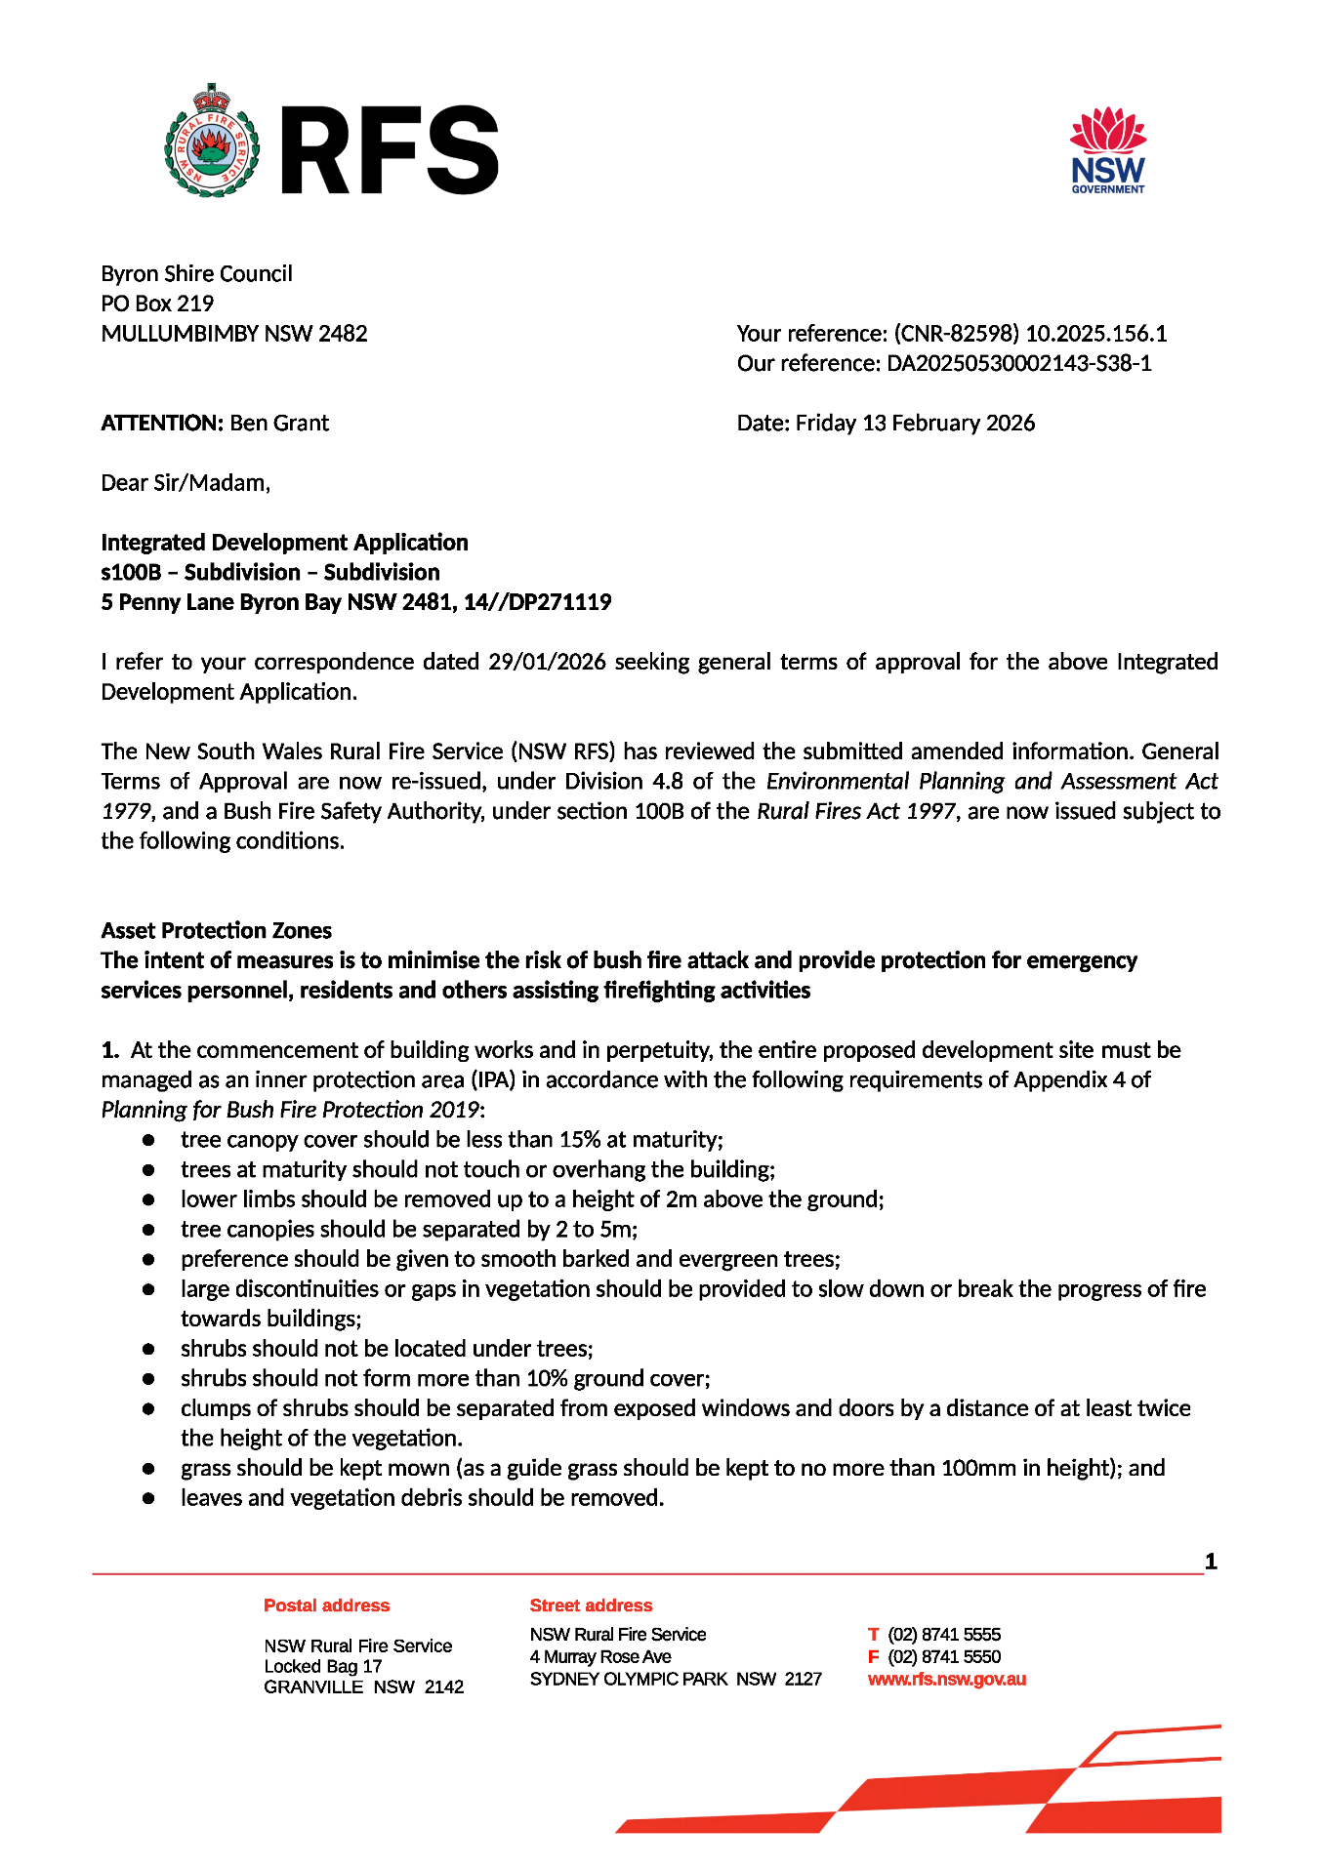

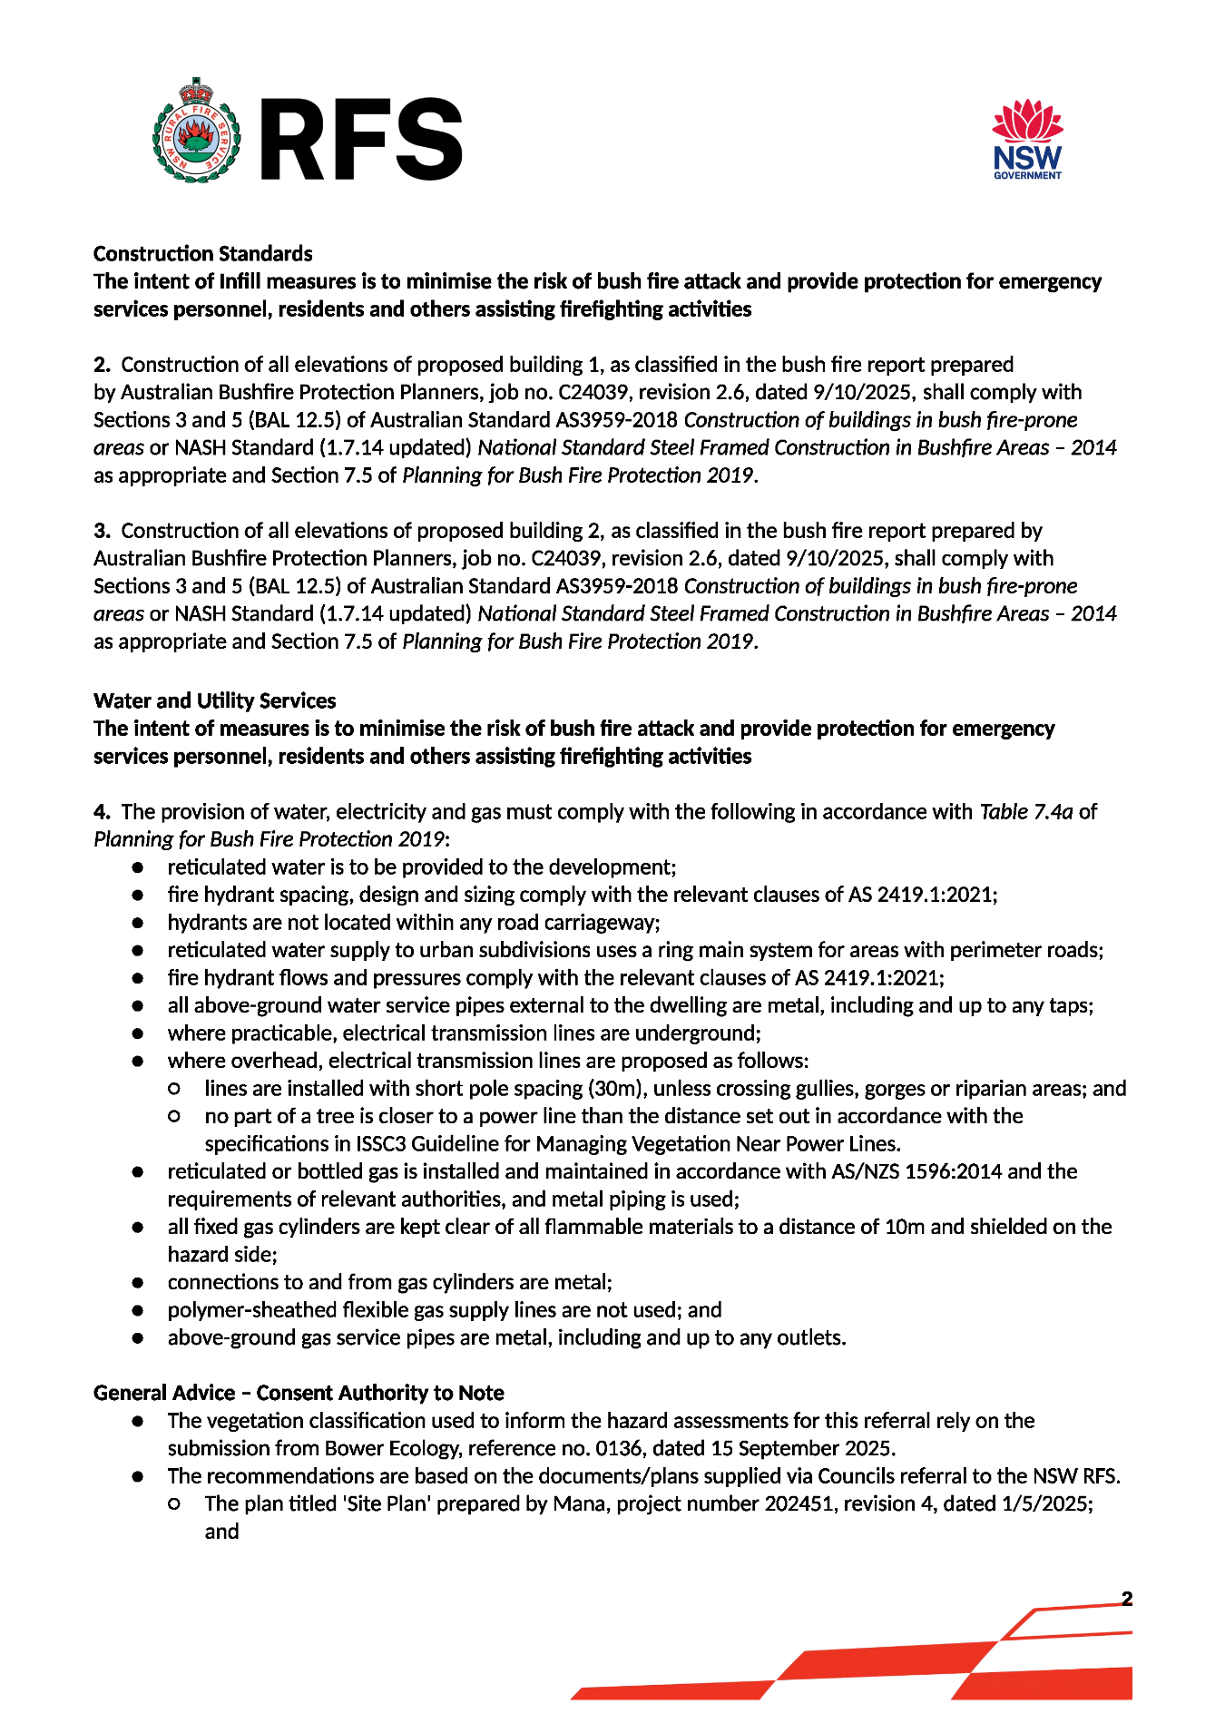

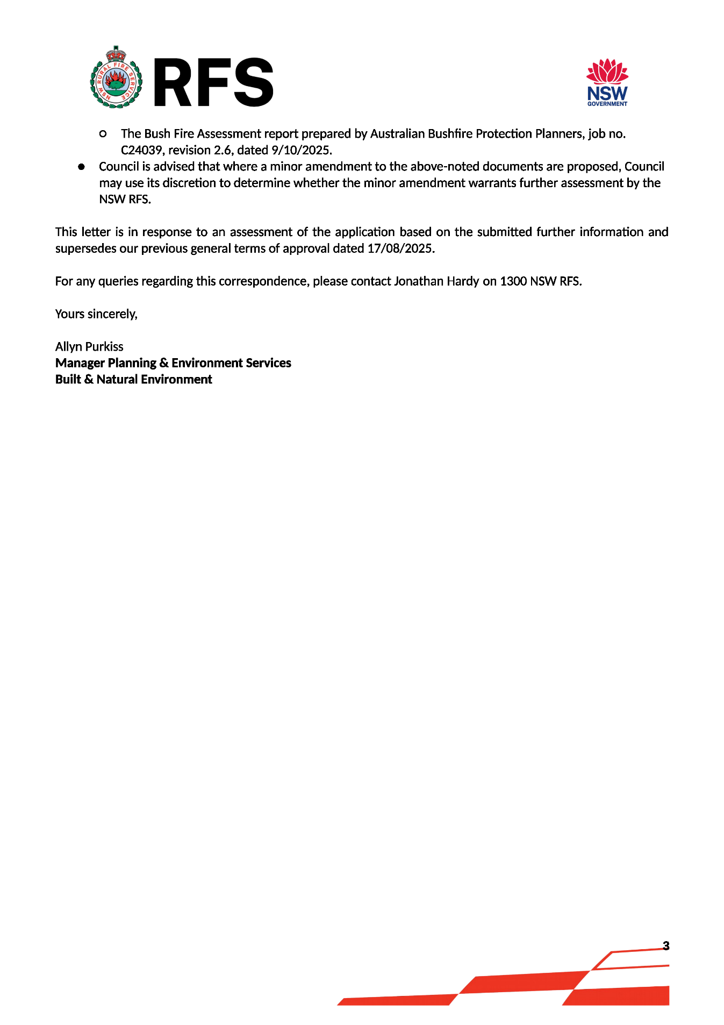

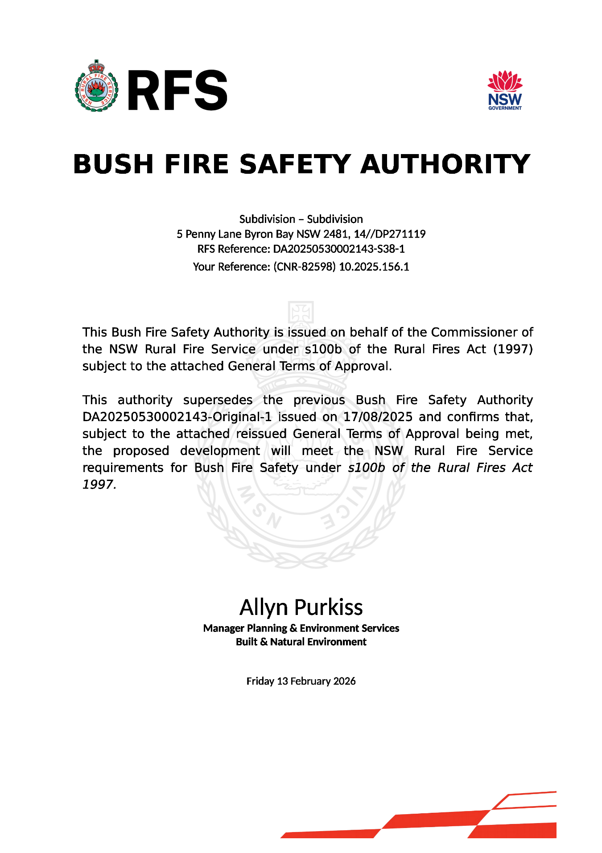

SCHEDULE 4. REASONS FOR DECISION, HOW COMMUNITY VIEWS WERE ADDRESSED
Note: From July 1 2018 Councils are required to give and publicly notify reasons for a range of planning decisions where they are deciding if development should proceed to help community members to see how their views have been taken into account and improve accountability to stakeholders. A statement of reasons for the determination of this application is provided below.

Statement of Reasons
The proposed development complies with the provisions of Byron Local Environmental Plan 2014.
The proposed development complies with relevant State Environmental Planning Policies
The proposed development complies with relevant provisions of Development Control Plan 2014
The proposed development complies with Environmental Planning & Assessment Regulation 2021 considerations.
The proposed development will not have significant adverse impact on the natural, built or social environment or economic impacts on the locality.
The proposed development is considered suitable for the proposed site.
The development application was notified/advertised in accordance with Council’s Community Participation Plan. Issues raised in the submissions have been addressed during assessment of the application.
The proposed development is unlikely to prejudice or compromise the public interest.

How community views were addressed
The DA was advertised in accordance with Council’s Community Participation Plan. The submissions received were considered on merit and addressed during assessment of the application. To view the considerations, please contact Council to view a copy of the assessment report relating to this DA.

SCHEDULE 5. NOTES
Water payments under the Water Management Act 2000
Charges will be calculated based on the additional water and sewerage load that the proposed development generates, shown in Equivalent Tenements (ET) by the following table:
ADDITIONAL WATER & SEWER LOAD OF DEVELOPMENT
(ET Policy 2022)
Water | 54.18 ET
Bulk Water | 54.18 ET
Sewer | 63.20 ET

NB: Information regarding Development Servicing charges can be found on the Byron Shire Council website (https://www.byron.nsw.gov.au/Development-Business/Building-Construction/Plumbing-Sewage/Calculate-the-cost-of-an-Equivalent-Tenement).

These charges will enable you to calculate the total contribution charges payable when you are ready to pay them. Developer charges will be calculated in accordance with the Development Servicing Plan applicable at the date of payment.

S7.11 Schedule of Development Contributions
The following contributions are current at the date of this consent. The contributions payable will be adjusted in accordance with the relevant plan and the amount payable will be calculated on the basis of the contribution rates that are applicable at the time of payment. The current contribution rates are available from Council offices during office hours.

Payments will be accepted through BPAY, over the telephone or in person at Council’s administration building. You will need to complete the Developer Contributions update and payment request form to confirm the total contribution amount due and request an invoice with payment details.

Construction Certificate required:
This development consent is issued under the Environmental Planning and Assessment Act 1979 and does not relate to structural aspects or specifications of the building under the Building Code of Australia. All buildings and alterations require the issue of a Construction Certificate prior to works commencing. Application forms are available from the customer services counter or Council’s website www.byron.nsw.gov.au

Principal Certifying Authority:
Work must not commence until the applicant has:-
a. appointed a Principal Certifying Authority (if the Council is not the PCA); and
b. given Council at least two days notice of the intention to commence the erection of the building. Notice must be given by using the prescribed ‘Form 7’.
c. notified the Principal Certifying Authority of the Compliance with Part 6 of the Home Building Act 1989.

Occupation Certificate required:
The building must not be occupied until the Principal Certifying Authority has issued an Occupation Certificate.

Protection of the Environment Operations Act 1997:
It is an offence under the provisions of the Protection of the Environment Operations Act 1997 to act in a manner causing, or likely to cause, harm to the environment. Anyone allowing material to enter a waterway or leaving material where it can be washed off-site may be subject to a penalty infringement notice (“on-the-spot fine”) or prosecution.

Penalties apply for failure to comply with development consents
Failure to comply with conditions of development consent may lead to an on the spot fine being issued pursuant to section 4.2(1) of the Environmental Planning & Assessment Act 1979 or prosecution pursuant to section 9.50 of the Environmental Planning & Assessment Act 1979.

Plumbing Standards and requirements.
All Plumbing, Water Supply, Sewerage and Stormwater Works shall be installed in accordance with the Local Government Act 1993, Plumbers Code of Australia and AS/NZS 3500 Parts 0-5, the approved plans (any notations on those plans) and the approved specifications. Any plumbing inspections required under a Section 68 Approval are to occur in accordance with that approval.

Swimming pool discharge (reticulated systems)
Swimming pool waste - irrespective of the filtering system is to be disposed into the property’s house drainage - sewerage system via an overflow relief gully with a 100mm visible air gap in accordance with AS/NZS 3500.2, Section 10.9 & Figure 10.2.

This activity is now an exempt activity and does not require approval under Section 68 of the Local Government Act.

If however, site conditions prevent discharge through the existing gully and a new gully is required, this activity will require an approval under S68 before this work can commence.
Note also that this activity must be carried out by a licensed plumber.

Relics Provisions- Advice
Attention is directed to the NSW Heritage Act 1977 and the provisions of the Act in relation to the exposure of relics. The Act requires that if:

- a relic is suspected, or there are reasonable grounds to suspect a relic in ground, that is likely to be disturbed damaged or destroyed by excavation; and/or
- any relic is discovered in the course of excavation that will be disturbed, damaged or destroyed by further excavation;

Those responsible for the discovery must notify nominated management personnel who will in turn notify the Heritage Council of New South Wales or its delegate, the Office of Environment and Heritage, NSW Heritage Branch, and suspend work that might have the effect of disturbing, damaging or destroying such relic until the requirements of the NSW Heritage Council have been satisfied (ss139, 146).

